WIPRO TALENTNEXT PROGRAM
PBL HANDS-ON ASSIGNMENT
Name: M.VINAY
Roll No: 23BQ1A4951
PBL ID:DB_262790141
Date: 16-07-2026
Topic: Introduction to SQL(set operators)

1. Matrix query — job, salary for that job by department (10, 20, 30), and total salary for that job.
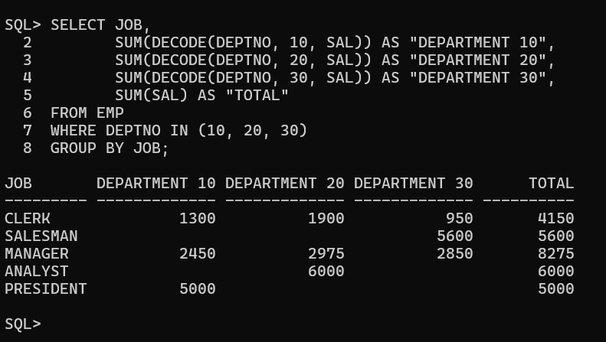

2. Using a set operator, display DEPTNO, SUM(SAL) for each dept, JOB, SUM(SAL) for each job, and total salary.
Since DEPTNO (number) and JOB (varchar) are different data types, convert DEPTNO to a character string so the columns match for the UNION.
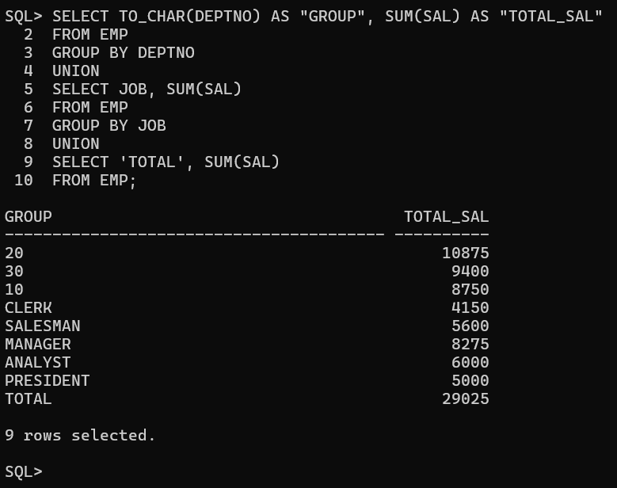

3. Using a set operator, display JOB and DEPTNO for employees working in deptno 20, 10, 30 — in that specific order.
Use UNION ALL (not UNION) because plain UNION automatically sorts results, which would break the required 20 → 10 → 30 order.

